**SonarQube with python project:**

🡺 To setup two VM (1. Jenkins, 2. SonarQube server’s)

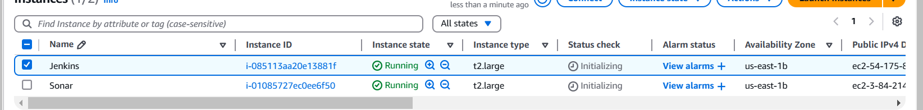

🡺 Setup in the SonarQube with docker container .

**Rafal Pipeline code:**

**pipeline {**

**agent any**

**environment {**

**SCANNER_HOME = tool 'sonar-scanner'**

**}**

**stages {**

**stage('git checkout') {**

**steps {**

**git branch: 'main', url: 'https://github.com/Jagan-18/Multi-Tier-Python-Postgres-main.git'**

**}**

**}**

**stage('Install Dependencies') {**

**steps {**

**sh '''**

**rm -rf # Remove any existing virtual environment**

**python3 -m venv venv # Create a new virtual environment**

**chmod -R 755 venv**

**bash -c "**

**source venv/bin/activate**

**pip install --upgrade pip**

**pip install -r requirements.txt**

**"**

**'''**

**}**

**}**

**stage('Tests') {**

**steps {**

**sh '''**

**bash -c "**

**source venv/bin/activate**

**pytest --cov=app --cov-report=xml**

**pytest --cov=app --cov-report=term-missing --disable-warnings**

**"**

**'''**

**}**

**}**

**stage('SonarQube Analysis') {**

**steps {**

**withSonarQubeEnv('sonar-server') {**

**sh '''**

**$SCANNER_HOME/bin/sonar-scanner -Dsonar.projectName=python-project \**

**-Dsonar.projectKey=python-project \**

**-Dsonar.exclusions=venv/** \**

**-Dsonar.sources=./ \**

**-Dsonar.python.coverage.reportPaths=coverage.xml**

**'''**

**}**

**}**

**}**

**}**

**}**

**------------------------------------------------------------------------------------------------------------------------------------------------**

* **Set upping the Community branch plugin with SonarQube.**

**🡺Before install plugin we need check container – sonar properties.**

**🡺Setup the plugin with docker container :**

**🡺 If we need to set up through a Docker container, we need to remove the old container from the server machine.**

**🡺Creating new container in server machine.**

* **docker run -d --name sonarqube -p 9000:9000 mc1arke/sonarqube-with-community-branch-plugin**

**Jenkins- Pipeline code**

**pipeline {**

**agent any**

**environment {**

**SCANNER_HOME = tool 'sonar-scanner'**

**}**

**stages {**

**stage ('git checkout') {**

**steps {**

**git branch: 'Dev', url: 'https://github.com/Jagan-18/Multi-Tier-Python-Postgres-main.git'**

**}**

**}**

**stage('Install Dependencies') {**

**steps {**

**sh '''**

**rm -rf # Remove any existing virtual environment**

**python3 -m venv venv # Create a new virtual environment**

**chmod -R 755 venv**

**bash -c "**

**source venv/bin/activate**

**pip install --upgrade pip**

**pip install -r requirements.txt**

**"**

**'''**

**}**

**}**

**stage('Tests') {**

**steps {**

**sh '''**

**bash -c "**

**source venv/bin/activate**

**pytest --cov=app --cov-report=xml**

**pytest --cov=app --cov-report=term-missing --disable-warnings**

**"**

**'''**

**}**

**}**

**stage('SonarQube Analysis') {**

**steps {**

**withSonarQubeEnv('sonar-server') {**

**sh '''**

**$SCANNER_HOME/bin/sonar-scanner -Dsonar.projectName=python-project \**

**-Dsonar.projectKey=python-project \**

**-Dsonar.exclusions=venv/** \**

**-Dsonar.sources=./ \**

**-Dsonar.branch.name=Dev \**

**-Dsonar.python.coverage.reportPaths=coverage.xml**

**'''**

**}**

**}**

**}**

**}**

**}**